Mandatory HandsOn
1.Spring-Rest-Handson

1). Hands on 1: Create a Spring Web Project using Maven
Code Implementation:

SpringLearnApplication.java

package com.cognizant.springlearn;

import org.springframework.boot.SpringApplication;
import org.springframework.boot.autoconfigure.SpringBootApplication;

@SpringBootApplication
public class SpringLearnApplication {

public static void main(String[] args) {
SpringApplication.run(SpringLearnApplication.class, args);
System.out.println("Oh Yes, It got started!!");
}

}

HelloController.java

package com.cognizant.springlearn.controller;

import org.springframework.web.bind.annotation.GetMapping;
import org.springframework.web.bind.annotation.RestController;

@RestController
public class HelloController {

@GetMapping("/")
public String hello() {
return "Hello There from Spring Boot!!";
}
}

Application.properties

server.port=8081

logging.level.org.springframework=INFO

pom.xml

<?xml version="1.0" encoding="UTF-8"?>
<project xmlns="http://maven.apache.org/POM/4.0.0"
xmlns:xsi="http://www.w3.org/2001/XMLSchema-instance"
xsi:schemaLocation="http://maven.apache.org/POM/4.0.0
http://maven.apache.org/xsd/maven-4.0.0.xsd">

<modelVersion>4.0.0</modelVersion>

<groupId>com.cognizant</groupId>
<artifactId>spring-learn</artifactId>
<version>1.0</version>
<packaging>jar</packaging>

<name>spring-learn</name>
<description>Spring Boot Web Application for Cognizant Hands-On</description>
<url>http://www.example.com</url>

<parent>
<groupId>org.springframework.boot</groupId>
<artifactId>spring-boot-starter-parent</artifactId>
<version>2.7.14</version>
<relativePath/>
</parent>

<properties>
<java.version>11</java.version>
</properties>

<dependencies>

<dependency>
<groupId>org.springframework.boot</groupId>
<artifactId>spring-boot-starter-web</artifactId>
</dependency>

<dependency>
<groupId>org.springframework.boot</groupId>
<artifactId>spring-boot-devtools</artifactId>
<scope>runtime</scope>
<optional>true</optional>
</dependency>

<dependency>
<groupId>org.springframework.boot</groupId>
<artifactId>spring-boot-starter-test</artifactId>
<scope>test</scope>
</dependency>
</dependencies>

<build>
<plugins>

<plugin>
<groupId>org.springframework.boot</groupId>
<artifactId>spring-boot-maven-plugin</artifactId>
</plugin>
</plugins>
</build>

</project>

OUTPUT:

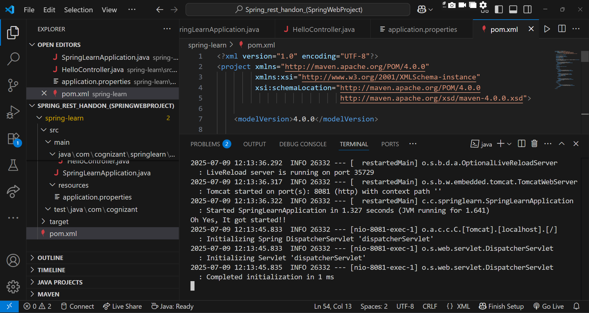

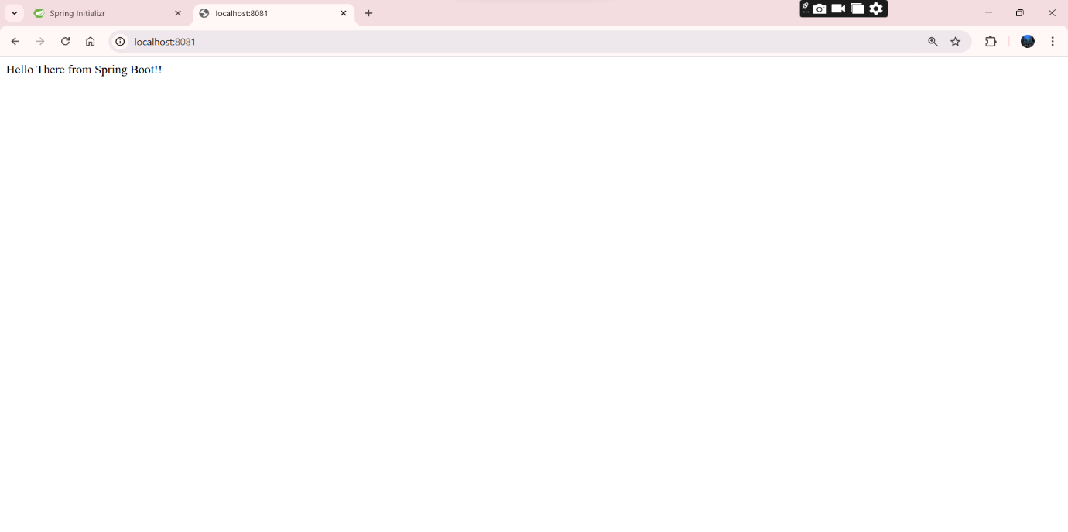
2). Hands on 4
Spring Core – Load Country from Spring Configuration XML

Code Implementation:

SpringLearnApplication.java

package com.cognizant.springlearn;

import com.cognizant.springlearn.model.Country;
import org.slf4j.Logger;
import org.slf4j.LoggerFactory;
import org.apache.log4j.xml.DOMConfigurator;
import org.springframework.context.ApplicationContext;
import org.springframework.context.support.ClassPathXmlApplicationContext;

public class SpringLearnApplication {

static {

DOMConfigurator.configure("src/main/resources/log4j.xml");
}

private static final Logger LOGGER = LoggerFactory.getLogger(SpringLearnApplication.class);

public static void main(String[] args) {
displayCountry();
}

public static void displayCountry() {
ApplicationContext context = new ClassPathXmlApplicationContext("country.xml");
Country country = context.getBean("country", Country.class);
LOGGER.debug("Country : {}", country.toString());
}
}

country.xml

<beans xmlns="http://www.springframework.org/schema/beans"
xmlns:xsi="http://www.w3.org/2001/XMLSchema-instance"
xsi:schemaLocation="http://www.springframework.org/schema/beans
http://www.springframework.org/schema/beans/spring-beans.xsd">

<bean id="country" class="com.cognizant.springlearn.model.Country">
<property name="code" value="IN" />
<property name="name" value="India" />
</bean>
</beans>
Log4j.xml

<?xml version="1.0" encoding="UTF-8"?>
<!DOCTYPE log4j:configuration SYSTEM "log4j.dtd">
<log4j:configuration xmlns:log4j="http://jakarta.apache.org/log4j/">

<appender name="console" class="org.apache.log4j.ConsoleAppender">
<layout class="org.apache.log4j.PatternLayout">
<param name="ConversionPattern" value="%d [%t] %-5p %c - %m%n"/>
</layout>
</appender>

<root>
<priority value="debug"/>
<appender-ref ref="console"/>
</root>

</log4j:configuration>

Country.java

package com.cognizant.springlearn.model;

import org.slf4j.Logger;
import org.slf4j.LoggerFactory;

public class Country {
private static final Logger LOGGER = LoggerFactory.getLogger(Country.class);

private String code;
private String name;

public Country() {
LOGGER.debug("Inside Country Constructor.");
}

public String getCode() {
LOGGER.debug("Inside getCode()");
return code;
}

public void setCode(String code) {
LOGGER.debug("Inside setCode()");
this.code = code;
}

public String getName() {
LOGGER.debug("Inside getName()");
return name;
}

public void setName(String name) {
LOGGER.debug("Inside setName()");
this.name = name;
}

@Override
public String toString() {
return "Country [code=" + code + ", name=" + name + "]";
}
}

pom.xml

<project xmlns="http://maven.apache.org/POM/4.0.0"
xmlns:xsi="http://www.w3.org/2001/XMLSchema-instance"
xsi:schemaLocation="http://maven.apache.org/POM/4.0.0
http://maven.apache.org/xsd/maven-4.0.0.xsd">

<modelVersion>4.0.0</modelVersion>

<groupId>com.cognizant</groupId>
<artifactId>SpringCountryApp</artifactId>
<version>1.0-SNAPSHOT</version>

<dependencies>
<!-- Spring Core -->
<dependency>
<groupId>org.springframework</groupId>
<artifactId>spring-context</artifactId>
<version>5.3.36</version>
</dependency>

<!-- SLF4J Logging -->
<dependency>
<groupId>org.slf4j</groupId>
<artifactId>slf4j-api</artifactId>
<version>1.7.36</version>
</dependency>

<dependency>
<groupId>log4j</groupId>
<artifactId>log4j</artifactId>
<version>1.2.17</version>
</dependency>

<dependency>
<groupId>org.slf4j</groupId>
<artifactId>slf4j-log4j12</artifactId>
<version>1.7.36</version>
</dependency>
</dependencies>

<build>
<plugins>
<plugin>
<groupId>org.codehaus.mojo</groupId>
<artifactId>exec-maven-plugin</artifactId>
<version>3.1.0</version>
<configuration>
<mainClass>com.cognizant.springlearn.SpringLearnApplication</mainClass>
</configuration>
</plugin>
</plugins>
</build>

</project>

OUTPUT:

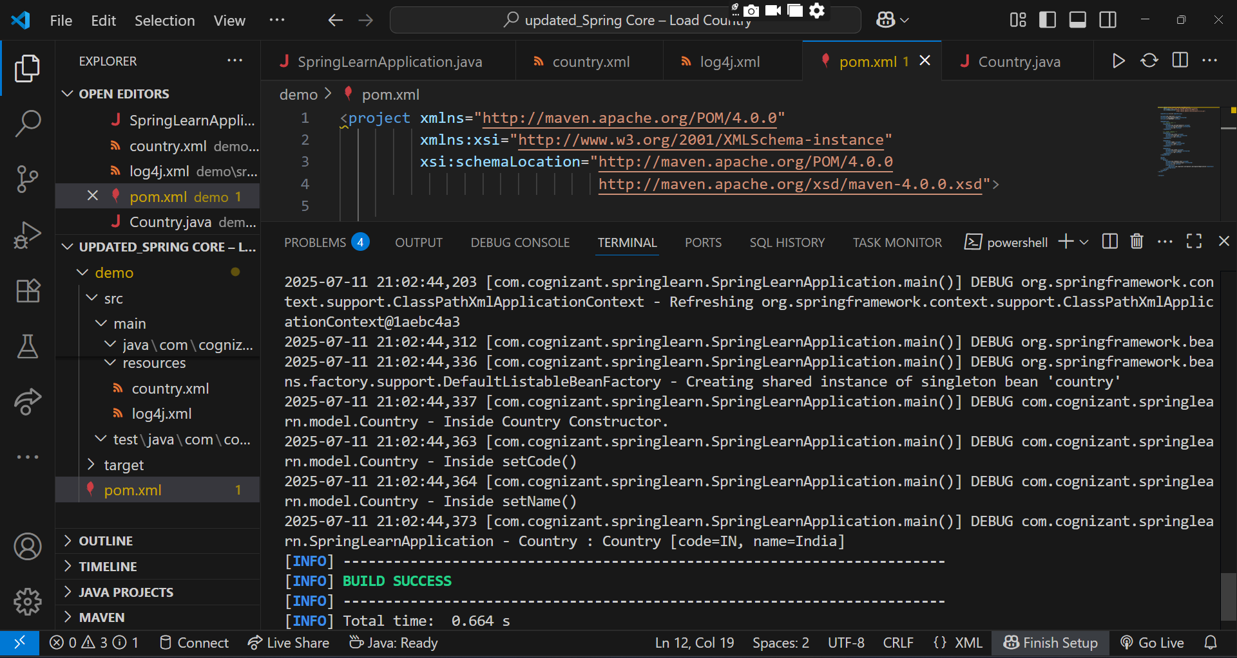

2.Spring-Rest-Handson

3). Hello World RESTful Web Service
Write a REST service in the spring learn application created earlier, that returns the text "Hello World!!" using Spring Web Framework. Refer details below:

Code Implementation:

SpringLearnApplication.java

package com.cognizant.springlearn;

import org.springframework.boot.SpringApplication;
import org.springframework.boot.autoconfigure.SpringBootApplication;

@SpringBootApplication
public class SpringLearnApplication {

public static void main(String[] args) {
SpringApplication.run(SpringLearnApplication.class, args);
}
}

HelloController.java

package com.cognizant.springlearn.controller;

import org.slf4j.Logger;
import org.slf4j.LoggerFactory;
import org.springframework.web.bind.annotation.GetMapping;
import org.springframework.web.bind.annotation.RestController;

@RestController
public class HelloController {

private static final Logger LOGGER = LoggerFactory.getLogger(HelloController.class);

@GetMapping("/hello")
public String sayHello() {
LOGGER.info("START: sayHello()");
String message = "Hello World!!";
LOGGER.info("END: sayHello()");
return message;
}
}

pom.xml

<?xml version="1.0" encoding="UTF-8"?>

<project xmlns="http://maven.apache.org/POM/4.0.0"
xmlns:xsi="http://www.w3.org/2001/XMLSchema-instance"
xsi:schemaLocation="http://maven.apache.org/POM/4.0.0
http://maven.apache.org/xsd/maven-4.0.0.xsd">

<modelVersion>4.0.0</modelVersion>

<groupId>com.cognizant</groupId>
<artifactId>spring-learn</artifactId>
<version>1.0</version>
<name>spring-learn</name>
<url>http://www.example.com</url>

<parent>
<groupId>org.springframework.boot</groupId>
<artifactId>spring-boot-starter-parent</artifactId>
<version>2.5.3</version>
<relativePath/> <!-- lookup parent from repository -->
</parent>

<properties>
<java.version>1.8</java.version>
<project.build.sourceEncoding>UTF-8</project.build.sourceEncoding>
</properties>

<dependencies>
<!-- Spring Boot Starter Web -->
<dependency>
<groupId>org.springframework.boot</groupId>
<artifactId>spring-boot-starter-web</artifactId>
</dependency>

<!-- Logging (already included in spring-boot-starter, but can be explicitly declared) -->
<dependency>
<groupId>org.springframework.boot</groupId>
<artifactId>spring-boot-starter-logging</artifactId>
</dependency>

<!-- JUnit for testing -->
<dependency>
<groupId>junit</groupId>
<artifactId>junit</artifactId>
<version>4.13.2</version>
<scope>test</scope>
</dependency>
</dependencies>

<build>
<plugins>
<!-- Spring Boot Maven Plugin -->
<plugin>
<groupId>org.springframework.boot</groupId>
<artifactId>spring-boot-maven-plugin</artifactId>
</plugin>

<!-- Maven Compiler Plugin -->
<plugin>
<groupId>org.apache.maven.plugins</groupId>
<artifactId>maven-compiler-plugin</artifactId>
<version>3.8.1</version>
<configuration>
<source>1.8</source>
<target>1.8</target>
</configuration>
</plugin>
</plugins>
</build>

</project>

Application.properties

server.port=8083

OUTPUT:

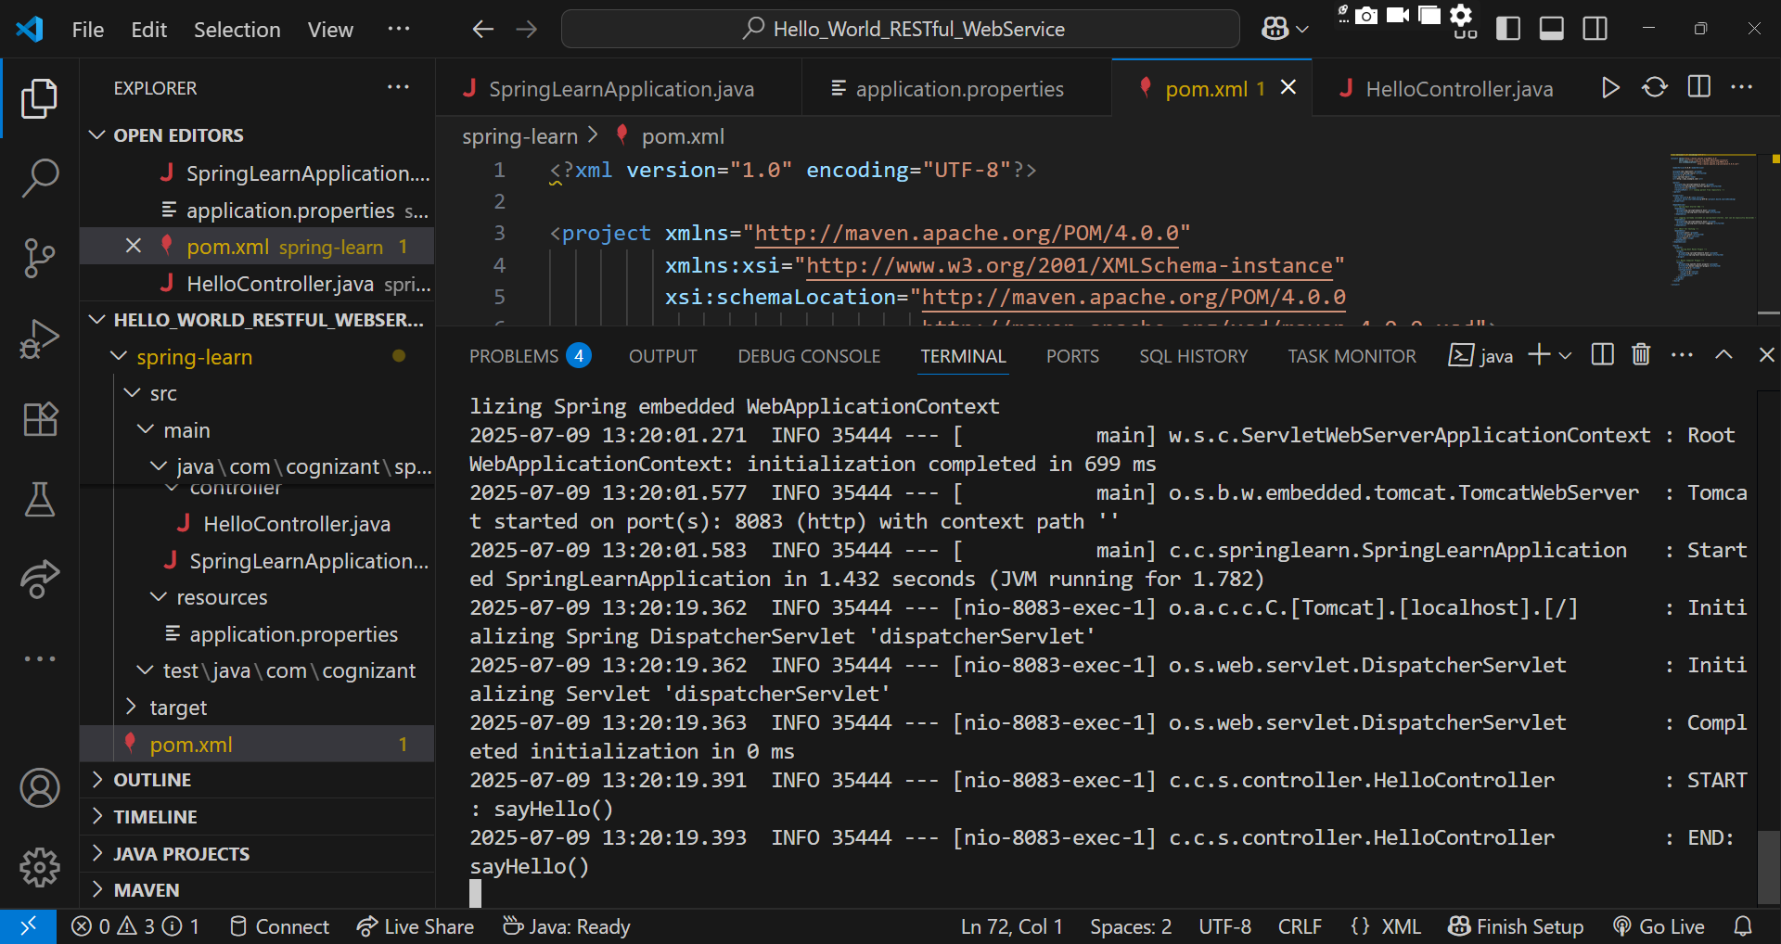

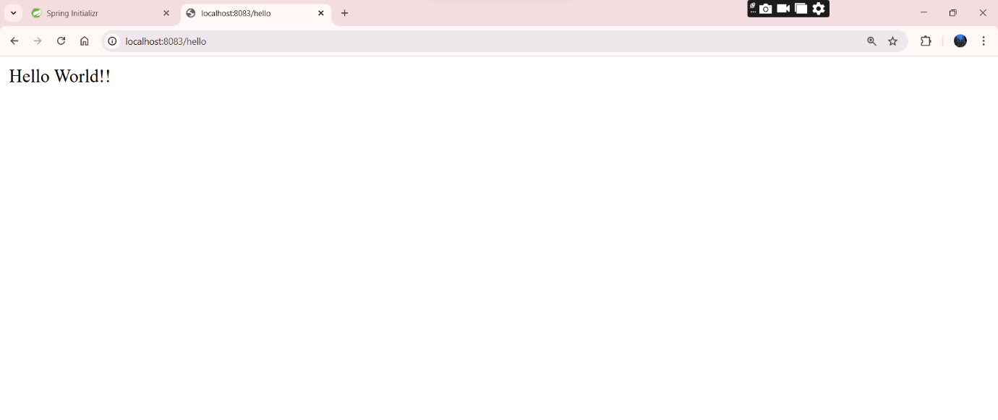

4). REST - Country Web Service
Write a REST service that returns India country details in the earlier created spring learn application.

Code Implementation:

SpringLearnApplication.java

package com.cognizant.springlearn;

import org.springframework.boot.SpringApplication;
import org.springframework.boot.autoconfigure.SpringBootApplication;

@SpringBootApplication
public class SpringLearnApplication {
public static void main(String[] args) {
SpringApplication.run(SpringLearnApplication.class, args);
}
}

CountryController.java

package com.cognizant.springlearn.controller;

import com.cognizant.springlearn.model.Country;
import org.springframework.beans.factory.xml.XmlBeanFactory;
import org.springframework.core.io.ClassPathResource;
import org.springframework.web.bind.annotation.RequestMapping;
import org.springframework.web.bind.annotation.RestController;

@RestController
public class CountryController {

@RequestMapping("/country")
public Country getCountryIndia() {
XmlBeanFactory factory = new XmlBeanFactory(new ClassPathResource("country.xml"));
Country country = (Country) factory.getBean("in");
return country;
}
}

Country.java

package com.cognizant.springlearn.model;

public class Country {
private String code;
private String name;

public Country() {}

public Country(String code, String name) {
this.code = code;
this.name = name;
}

public String getCode() {
return code;
}

public void setCode(String code) {
this.code = code;
}

public String getName() {
return name;
}

public void setName(String name) {
this.name = name;
}
}

country.xml

<?xml version="1.0" encoding="UTF-8"?>
<beans xmlns="http://www.springframework.org/schema/beans"
xmlns:xsi="http://www.w3.org/2001/XMLSchema-instance"
xsi:schemaLocation="http://www.springframework.org/schema/beans
http://www.springframework.org/schema/beans/spring-beans.xsd">

<bean id="in" class="com.cognizant.springlearn.model.Country">
<property name="code" value="IN"/>
<property name="name" value="India"/>
</bean>

</beans>

Application.properties

server.port=8083

samplerequest.http

GET http://localhost:8083/country
Accept: application/json

pom.xml

<?xml version="1.0" encoding="UTF-8"?>

<project xmlns="http://maven.apache.org/POM/4.0.0"
xmlns:xsi="http://www.w3.org/2001/XMLSchema-instance"
xsi:schemaLocation="http://maven.apache.org/POM/4.0.0
http://maven.apache.org/xsd/maven-4.0.0.xsd">

<modelVersion>4.0.0</modelVersion>

<groupId>com.cognizant</groupId>
<artifactId>spring-learn</artifactId>
<version>1.0</version>
<name>spring-learn</name>
<url>http://www.example.com</url>

<parent>
<groupId>org.springframework.boot</groupId>
<artifactId>spring-boot-starter-parent</artifactId>
<version>2.5.3</version>
<relativePath/>
</parent>

<properties>
<java.version>1.8</java.version>
<project.build.sourceEncoding>UTF-8</project.build.sourceEncoding>
</properties>

<dependencies>
<dependency>
<groupId>org.springframework.boot</groupId>
<artifactId>spring-boot-starter-web</artifactId>
</dependency>

<dependency>
<groupId>org.springframework.boot</groupId>
<artifactId>spring-boot-starter-logging</artifactId>
</dependency>

<dependency>
<groupId>junit</groupId>
<artifactId>junit</artifactId>
<version>4.13.2</version>
<scope>test</scope>
</dependency>
</dependencies>

<build>
<plugins>
<plugin>
<groupId>org.springframework.boot</groupId>
<artifactId>spring-boot-maven-plugin</artifactId>
<configuration>
<mainClass>com.cognizant.springlearn.SpringLearnApplication</mainClass>
</configuration>
</plugin>

<plugin>
<groupId>org.apache.maven.plugins</groupId>
<artifactId>maven-compiler-plugin</artifactId>
<version>3.8.1</version>
<configuration>
<source>1.8</source>
<target>1.8</target>
</configuration>
</plugin>
</plugins>
</build>

</project>

OUTPUT:

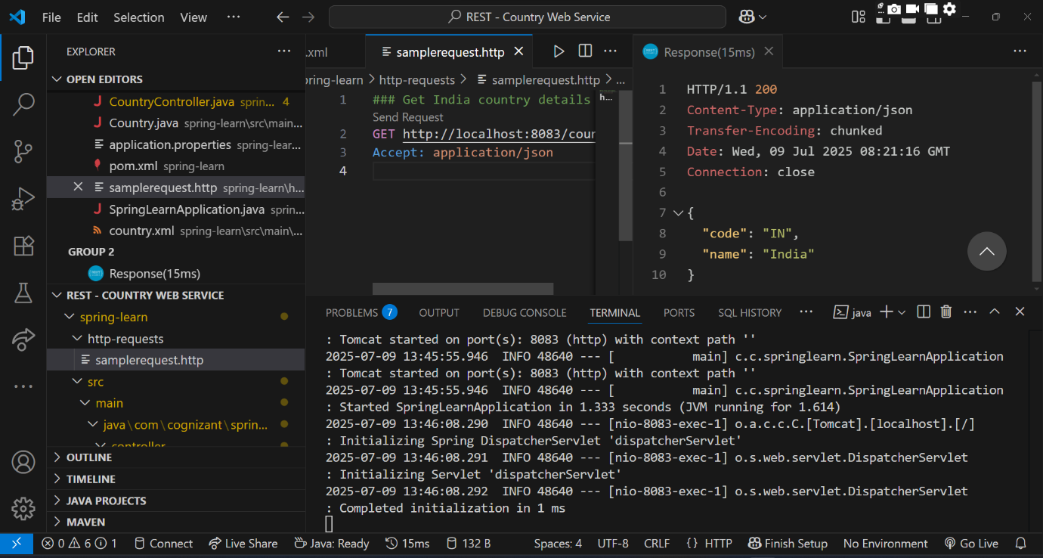

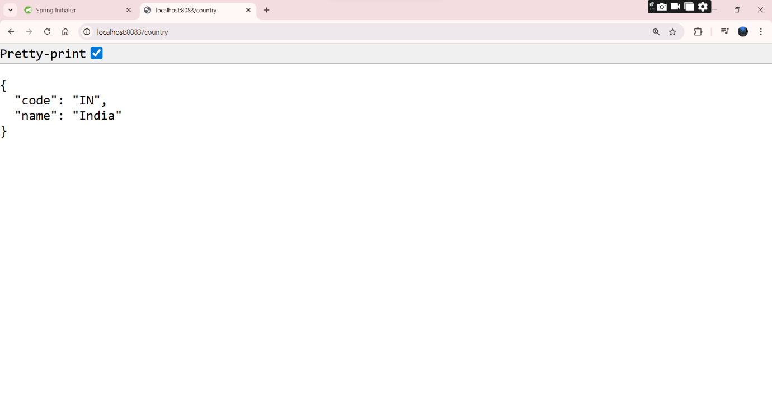

5). REST - Get country based on country code
Write a REST service that returns a specific country based on country code. The country code should be case insensitive.

Code Implementation:

SpringLearnApplication.java

package com.cognizant.springlearn;

import org.springframework.boot.SpringApplication;
import org.springframework.boot.autoconfigure.SpringBootApplication;
import org.springframework.context.annotation.ImportResource;

@SpringBootApplication
@ImportResource("classpath:country.xml")
public class SpringLearnApplication {
public static void main(String[] args) {
SpringApplication.run(SpringLearnApplication.class, args);
}
}

CountryController.java

package com.cognizant.springlearn.controller;

import com.cognizant.springlearn.model.Country;
import com.cognizant.springlearn.service.CountryService;
import org.springframework.beans.factory.annotation.Autowired;
import org.springframework.web.bind.annotation.*;

@RestController
public class CountryController {

@Autowired
private CountryService countryService;

@GetMapping("/countries/{code}")
public Country getCountry(@PathVariable String code) {
return countryService.getCountry(code);
}
}

CountryService.java

package com.cognizant.springlearn.service;

import com.cognizant.springlearn.model.Country;
import org.springframework.beans.factory.annotation.Autowired;
import org.springframework.context.ApplicationContext;
import org.springframework.stereotype.Service;

import java.util.List;

@Service
public class CountryService {

@Autowired
private ApplicationContext context;

public Country getCountry(String code) {
List<Country> countryList = (List<Country>) context.getBean("countryList");

return countryList.stream()
.filter(country -> country.getCode().equalsIgnoreCase(code))
.findFirst()
.orElseThrow(() -> new RuntimeException("Country not found with code: " + code));
}
}

Country.java

package com.cognizant.springlearn.model;

public class Country {
private String code;
private String name;

public Country() {}

public Country(String code, String name) {
this.code = code;
this.name = name;
}

public String getCode() {
return code;
}

public void setCode(String code) {
this.code = code.toUpperCase(); // Optional
}

public String getName() {
return name;
}

public void setName(String name) {
this.name = name;
}
}

Country.xml

<beans xmlns="http://www.springframework.org/schema/beans"
xmlns:xsi="http://www.w3.org/2001/XMLSchema-instance"
xsi:schemaLocation="http://www.springframework.org/schema/beans
http://www.springframework.org/schema/beans/spring-beans.xsd">

<bean id="countryList" class="java.util.ArrayList">
<constructor-arg>
<list>
<bean class="com.cognizant.springlearn.model.Country">
<property name="code" value="IN"/>
<property name="name" value="India"/>
</bean>
<bean class="com.cognizant.springlearn.model.Country">
<property name="code" value="US"/>
<property name="name" value="United States"/>
</bean>
<bean class="com.cognizant.springlearn.model.Country">
<property name="code" value="FR"/>
<property name="name" value="France"/>
</bean>
</list>
</constructor-arg>
</bean>
</beans>

Application.properties

server.port=8083

samplerequest.java

GET http://localhost:8083/countries/in
Accept: application/json

pom.xml

<project xmlns="http://maven.apache.org/POM/4.0.0"
xmlns:xsi="http://www.w3.org/2001/XMLSchema-instance"
xsi:schemaLocation="http://maven.apache.org/POM/4.0.0
http://maven.apache.org/xsd/maven-4.0.0.xsd">
<modelVersion>4.0.0</modelVersion>
<groupId>com.cognizant</groupId>
<artifactId>spring-learn</artifactId>
<version>0.0.1-SNAPSHOT</version>
<name>spring-learn</name>
<description>Spring Boot Country Service</description>

<parent>
<groupId>org.springframework.boot</groupId>
<artifactId>spring-boot-starter-parent</artifactId>
<version>3.1.2</version>
</parent>

<dependencies>
<dependency>
<groupId>org.springframework.boot</groupId>
<artifactId>spring-boot-starter-web</artifactId>
</dependency>

<dependency>
<groupId>org.springframework.boot</groupId>
<artifactId>spring-boot-starter</artifactId>
</dependency>

<dependency>
<groupId>org.springframework</groupId>
<artifactId>spring-context</artifactId>
</dependency>

<dependency>
<groupId>com.fasterxml.jackson.core</groupId>
<artifactId>jackson-databind</artifactId>
</dependency>
</dependencies>
</project>

OUTPUT:

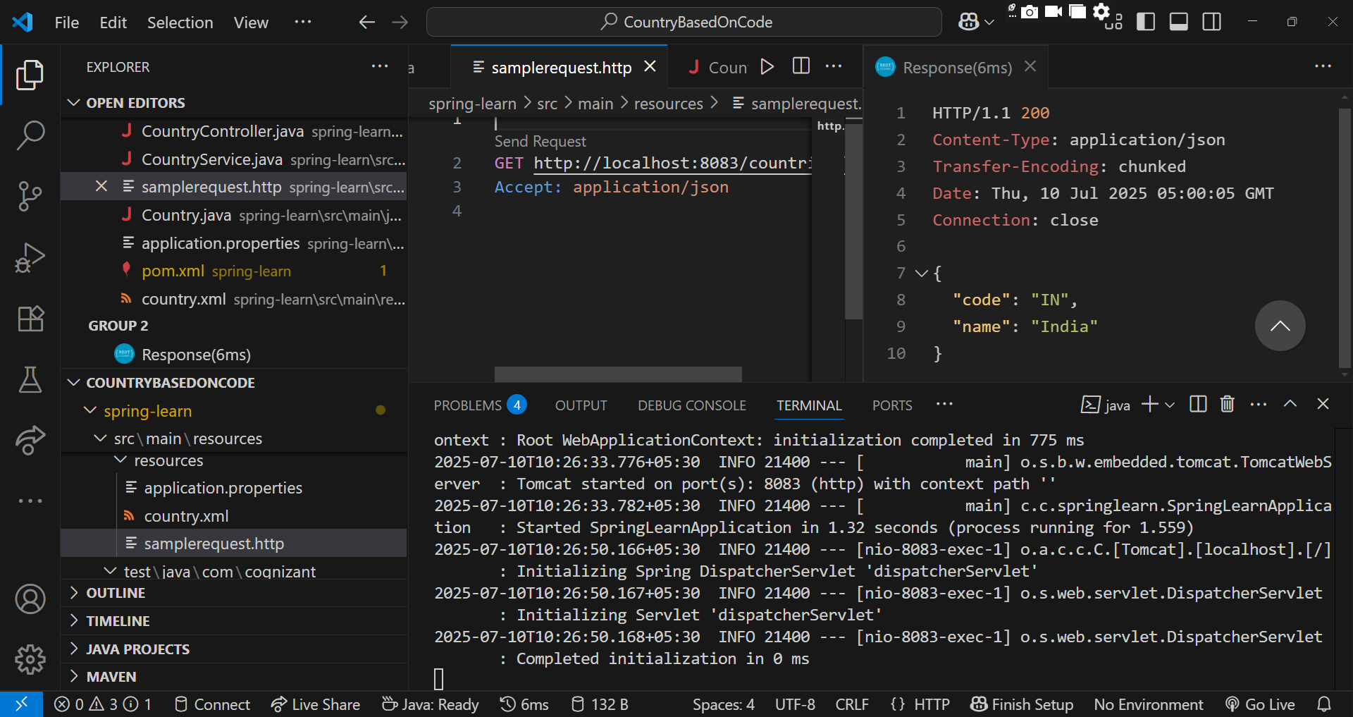

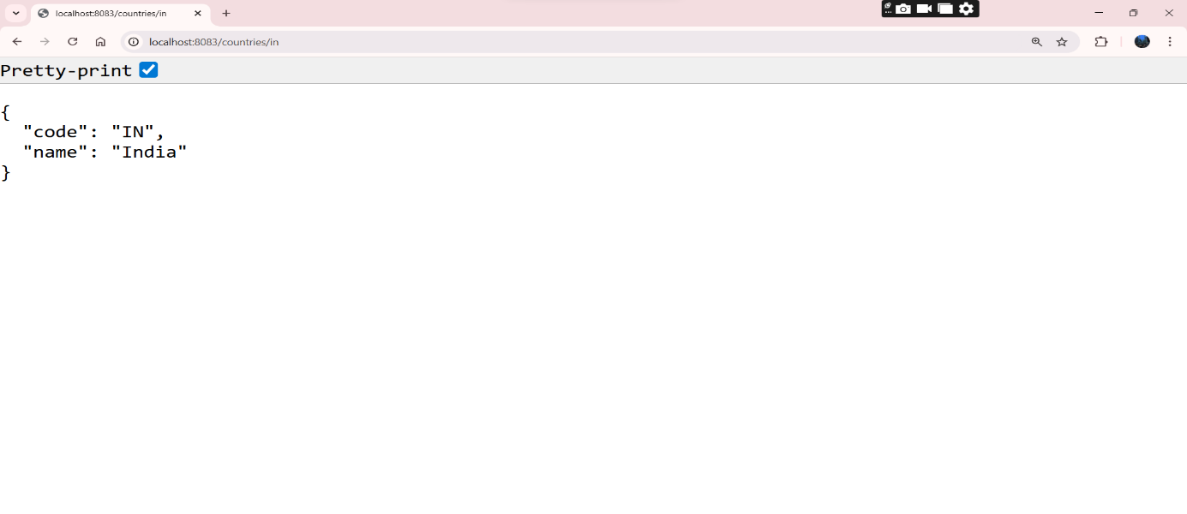

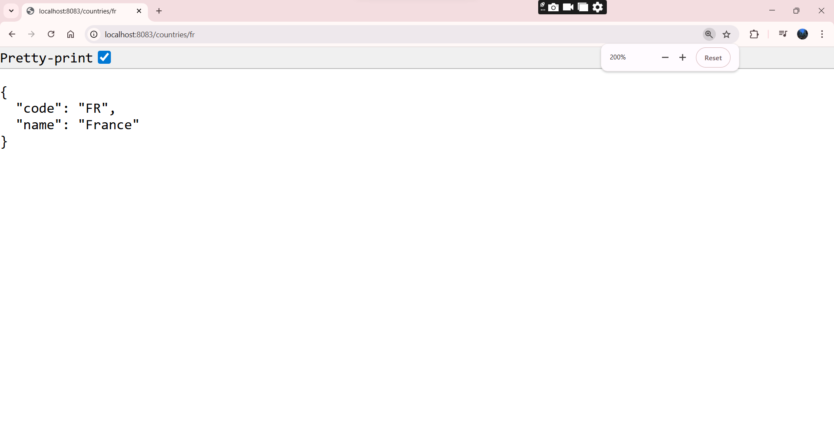

JWT HandsOn

6). Create authentication service that returns JWT

JwtAuthApplication.java

package com.example.jwtauth;

import org.springframework.boot.SpringApplication;
import org.springframework.boot.autoconfigure.SpringBootApplication;

@SpringBootApplication
public class JwtAuthApplication {
public static void main(String[] args) {
SpringApplication.run(JwtAuthApplication.class, args);
}
}

SecurityConfig.java

package com.example.jwtauth.config;

import org.springframework.context.annotation.Bean;
import org.springframework.context.annotation.Configuration;
import org.springframework.security.config.annotation.web.builders.HttpSecurity;
import org.springframework.security.web.SecurityFilterChain;
import org.springframework.security.core.userdetails.User;
import org.springframework.security.core.userdetails.UserDetailsService;
import org.springframework.security.provisioning.InMemoryUserDetailsManager;
import org.springframework.security.crypto.password.PasswordEncoder;
import org.springframework.security.crypto.bcrypt.BCryptPasswordEncoder;

@Configuration
public class SecurityConfig {

@Bean
public UserDetailsService userDetailsService(PasswordEncoder encoder) {
return new InMemoryUserDetailsManager(
User.withUsername("user")
.password(encoder.encode("pwd"))
.roles("USER")
.build()
);
}

@Bean
public PasswordEncoder passwordEncoder() {
return new BCryptPasswordEncoder();
}

@Bean
public SecurityFilterChain filterChain(HttpSecurity http) throws Exception {
http.csrf().disable()
.authorizeHttpRequests()
.requestMatchers("/authenticate").authenticated()
.anyRequest().permitAll()
.and()
.httpBasic();
return http.build();
}
}

AuthController.java

package com.example.jwtauth.controller;

import com.example.jwtauth.model.AuthResponse;
import com.example.jwtauth.service.JwtService;
import com.example.jwtauth.util.Base64DecoderUtil;
import org.springframework.beans.factory.annotation.Autowired;
import org.springframework.http.ResponseEntity;
import org.springframework.security.authentication.AuthenticationManager;
import org.springframework.security.core.userdetails.UserDetailsService;
import org.springframework.security.core.userdetails.UserDetails;
import org.springframework.web.bind.annotation.*;

import jakarta.servlet.http.HttpServletRequest;

@RestController
public class AuthController {

@Autowired
private JwtService jwtService;

@Autowired
private UserDetailsService userDetailsService;

@GetMapping("/authenticate")
public ResponseEntity<AuthResponse> authenticate(HttpServletRequest request) {
String authHeader = request.getHeader("Authorization");

if (authHeader != null && authHeader.startsWith("Basic ")) {
String[] credentials = Base64DecoderUtil.decodeBasicAuth(authHeader);
String username = credentials[0];
String password = credentials[1];

// Get user (password check already handled by Spring Security filter)
UserDetails user = userDetailsService.loadUserByUsername(username);

// Generate and return token
String token = jwtService.generateToken(user.getUsername());
return ResponseEntity.ok(new AuthResponse(token));
}

return ResponseEntity.status(401).build();
}
}

JwtService.java

package com.example.jwtauth.service;

import io.jsonwebtoken.Jwts;
import io.jsonwebtoken.SignatureAlgorithm;
import io.jsonwebtoken.security.Keys;
import org.springframework.stereotype.Service;

import java.security.Key;
import java.util.Date;

@Service
public class JwtService {

private static final Key SECRET_KEY = Keys.secretKeyFor(SignatureAlgorithm.HS256);

public String generateToken(String username) {
return Jwts.builder()
.setSubject(username)
.setIssuer("NutriHive Auth")
.setIssuedAt(new Date(System.currentTimeMillis()))
.setExpiration(new Date(System.currentTimeMillis() + 1000 * 60 * 60 * 10)) // 10 hours
.signWith(SECRET_KEY)
.compact();
}
}

AuthResponse.java

package com.example.jwtauth.model;

public class AuthResponse {
private String token;

public AuthResponse(String token) {
this.token = token;
}

public String getToken() {
return token;
}

public void setToken(String token) {
this.token = token;
}
}

Base64DecoderUtil.java

package com.example.jwtauth.util;

import java.util.Base64;

public class Base64DecoderUtil {
public static String[] decodeBasicAuth(String authHeader) {
String base64Credentials = authHeader.substring("Basic ".length());
byte[] decodedBytes = Base64.getDecoder().decode(base64Credentials);
String decoded = new String(decodedBytes);
return decoded.split(":", 2);
}
}

application.properties

server.port=8181
spring.main.allow-bean-definition-overriding=true

pom.xml

<?xml version="1.0" encoding="UTF-8"?>
<project xmlns="http://maven.apache.org/POM/4.0.0"
xmlns:xsi="http://www.w3.org/2001/XMLSchema-instance"
xsi:schemaLocation="http://maven.apache.org/POM/4.0.0
http://maven.apache.org/xsd/maven-4.0.0.xsd">

<modelVersion>4.0.0</modelVersion>

<parent>
<groupId>org.springframework.boot</groupId>
<artifactId>spring-boot-starter-parent</artifactId>
<version>3.1.3</version>
<relativePath/>
</parent>

<groupId>com.example</groupId>
<artifactId>jwt-auth-system</artifactId>
<version>1.0</version>
<name>jwt-auth-system</name>
<packaging>jar</packaging>

<properties>
<java.version>17</java.version>
</properties>

<dependencies>
<dependency>
<groupId>org.springframework.boot</groupId>
<artifactId>spring-boot-starter-web</artifactId>
</dependency>

<dependency>
<groupId>org.springframework.boot</groupId>
<artifactId>spring-boot-starter-security</artifactId>
</dependency>

<dependency>
<groupId>io.jsonwebtoken</groupId>
<artifactId>jjwt-api</artifactId>
<version>0.11.5</version>
</dependency>
<dependency>
<groupId>io.jsonwebtoken</groupId>
<artifactId>jjwt-impl</artifactId>
<version>0.11.5</version>
<scope>runtime</scope>
</dependency>
<dependency>
<groupId>io.jsonwebtoken</groupId>
<artifactId>jjwt-jackson</artifactId>
<version>0.11.5</version>
<scope>runtime</scope>
</dependency>

<dependency>
<groupId>org.springframework.boot</groupId>
<artifactId>spring-boot-starter-test</artifactId>
<scope>test</scope>
</dependency>
</dependencies>

<build>
<plugins>
<plugin>
<groupId>org.springframework.boot</groupId>
<artifactId>spring-boot-maven-plugin</artifactId>
</plugin>
</plugins>
</build>

</project>

OUTPUT:

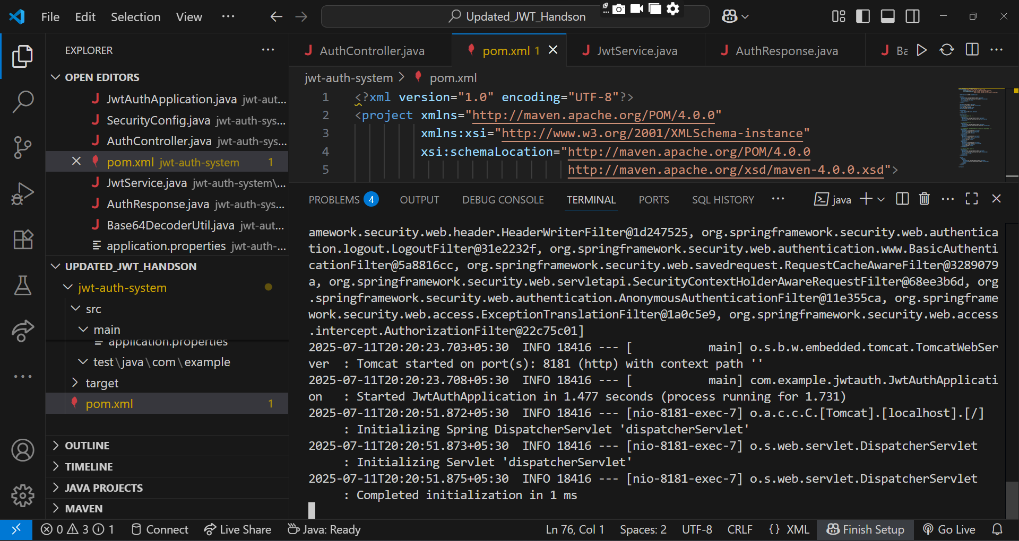

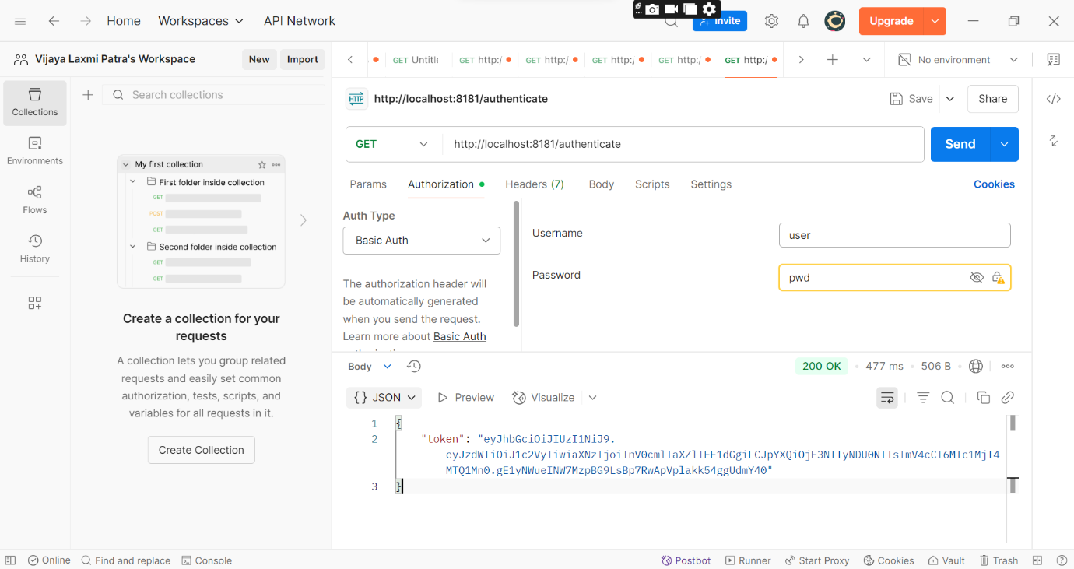

Additional Important HandsOn
3.Spring-Rest-HandsOn

1). Problem Statement - Display Employee List and Edit Employee form using RESTful Web Service

EmployeeRestApplication.java

package com.example.employee;

import org.springframework.boot.SpringApplication;
import org.springframework.boot.autoconfigure.SpringBootApplication;

@SpringBootApplication
public class EmployeeRestApplication {
public static void main(String[] args) {
SpringApplication.run(EmployeeRestApplication.class, args);
}
}

AppConfig.java

package com.example.employee.config;

import org.springframework.context.annotation.Bean;
import org.springframework.context.annotation.Configuration;
import org.springframework.context.support.ClassPathXmlApplicationContext;

import java.util.List;
import com.example.employee.model.Employee;

@Configuration
public class AppConfig {

@Bean
public List<Employee> employeeList() {
ClassPathXmlApplicationContext context =
new ClassPathXmlApplicationContext("employee.xml");
return (List<Employee>) context.getBean("employeeList");
}
}

EmployeeController.java

package com.example.employee.controller;

import com.example.employee.model.Employee;
import com.example.employee.service.EmployeeService;
import org.springframework.web.bind.annotation.*;

import java.util.List;

@RestController
@RequestMapping("/api/employees")
@CrossOrigin(origins = "http://localhost:56373")

public class EmployeeController {

private final EmployeeService service;

public EmployeeController(EmployeeService service) {
this.service = service;
}

@GetMapping
public List<Employee> getAll() {
return service.getAll();
}

@GetMapping("/{id}")
public Employee getById(@PathVariable int id) {
return service.getById(id);
}

@PutMapping("/{id}")
public Employee updateEmployee(@PathVariable int id, @RequestBody Employee updatedEmp) {
return service.updateEmployee(id, updatedEmp);
}
}

EmployeeService.java

package com.example.employee.service;

import com.example.employee.model.Employee;
import org.springframework.stereotype.Service;

import java.util.ArrayList;
import java.util.Arrays;
import java.util.List;

@Service
public class EmployeeService {
private List<Employee> employeeList = new ArrayList<>(
Arrays.asList(
new Employee(1, "Vanya Sen", "Software Engineer"),
new Employee(2, "Aryan Bhatiya", "Tester")
)
);

public List<Employee> getAll() {
return employeeList;
}

public Employee getById(int id) {
return employeeList.stream()
.filter(e -> e.getId() == id)
.findFirst()
.orElse(null);
}

public Employee updateEmployee(int id, Employee updatedEmp) {
for (int i = 0; i < employeeList.size(); i++) {
if (employeeList.get(i).getId() == id) {
employeeList.get(i).setName(updatedEmp.getName());
employeeList.get(i).setPosition(updatedEmp.getPosition());
return employeeList.get(i);
}
}
return null;
}
}

EmployeeRestApplication.service

package com.example.employee;

import org.springframework.boot.SpringApplication;
import org.springframework.boot.autoconfigure.SpringBootApplication;

@SpringBootApplication
public class EmployeeRestApplication {
public static void main(String[] args) {
SpringApplication.run(EmployeeRestApplication.class, args);
}
}

application.properties

server.port=8081

employee.xml

<?xml version="1.0" encoding="UTF-8"?>
<beans xmlns="http://www.springframework.org/schema/beans"
xmlns:xsi="http://www.w3.org/2001/XMLSchema-instance"
xsi:schemaLocation="http://www.springframework.org/schema/beans
https://www.springframework.org/schema/beans/spring-beans.xsd">

<bean id="employee1" class="com.example.employee.model.Employee">
<property name="id" value="1"/>
<property name="name" value="Aryan Bhatiya"/>
<property name="position" value="HR"/>
</bean>

<bean id="employee2" class="com.example.employee.model.Employee">
<property name="id" value="2"/>
<property name="name" value="Vanya Sen"/>
<property name="position" value="IT"/>
</bean>

<bean id="employeeList" class="java.util.ArrayList">
<constructor-arg>
<list>
<ref bean="employee1"/>
<ref bean="employee2"/>
</list>
</constructor-arg>
</bean>
</beans>

pom.xml

<?xml version="1.0" encoding="UTF-8"?>
<project xmlns="http://maven.apache.org/POM/4.0.0"
xmlns:xsi="http://www.w3.org/2001/XMLSchema-instance"
xsi:schemaLocation="http://maven.apache.org/POM/4.0.0
http://maven.apache.org/xsd/maven-4.0.0.xsd">

<modelVersion>4.0.0</modelVersion>

<groupId>com.example</groupId>
<artifactId>employee-rest</artifactId>
<version>1.0.0</version>
<name>employee-rest</name>
<description>Spring Boot REST API serving static XML-based employee data</description>

<parent>
<groupId>org.springframework.boot</groupId>
<artifactId>spring-boot-starter-parent</artifactId>
<version>3.2.5</version>
<relativePath/>
</parent>

<properties>
<java.version>17</java.version>
<project.build.sourceEncoding>UTF-8</project.build.sourceEncoding>
</properties>

<dependencies>

<dependency>
<groupId>org.springframework.boot</groupId>
<artifactId>spring-boot-starter-web</artifactId>
</dependency>

<dependency>
<groupId>org.springframework</groupId>
<artifactId>spring-context</artifactId>
</dependency>

<dependency>
<groupId>org.springframework.boot</groupId>
<artifactId>spring-boot-starter-test</artifactId>
<scope>test</scope>
</dependency>

</dependencies>

<build>
<plugins>

<plugin>
<groupId>org.springframework.boot</groupId>
<artifactId>spring-boot-maven-plugin</artifactId>
<version>3.2.5</version>
</plugin>
</plugins>
</build>

</project>
OUTPUT:

In Backend:

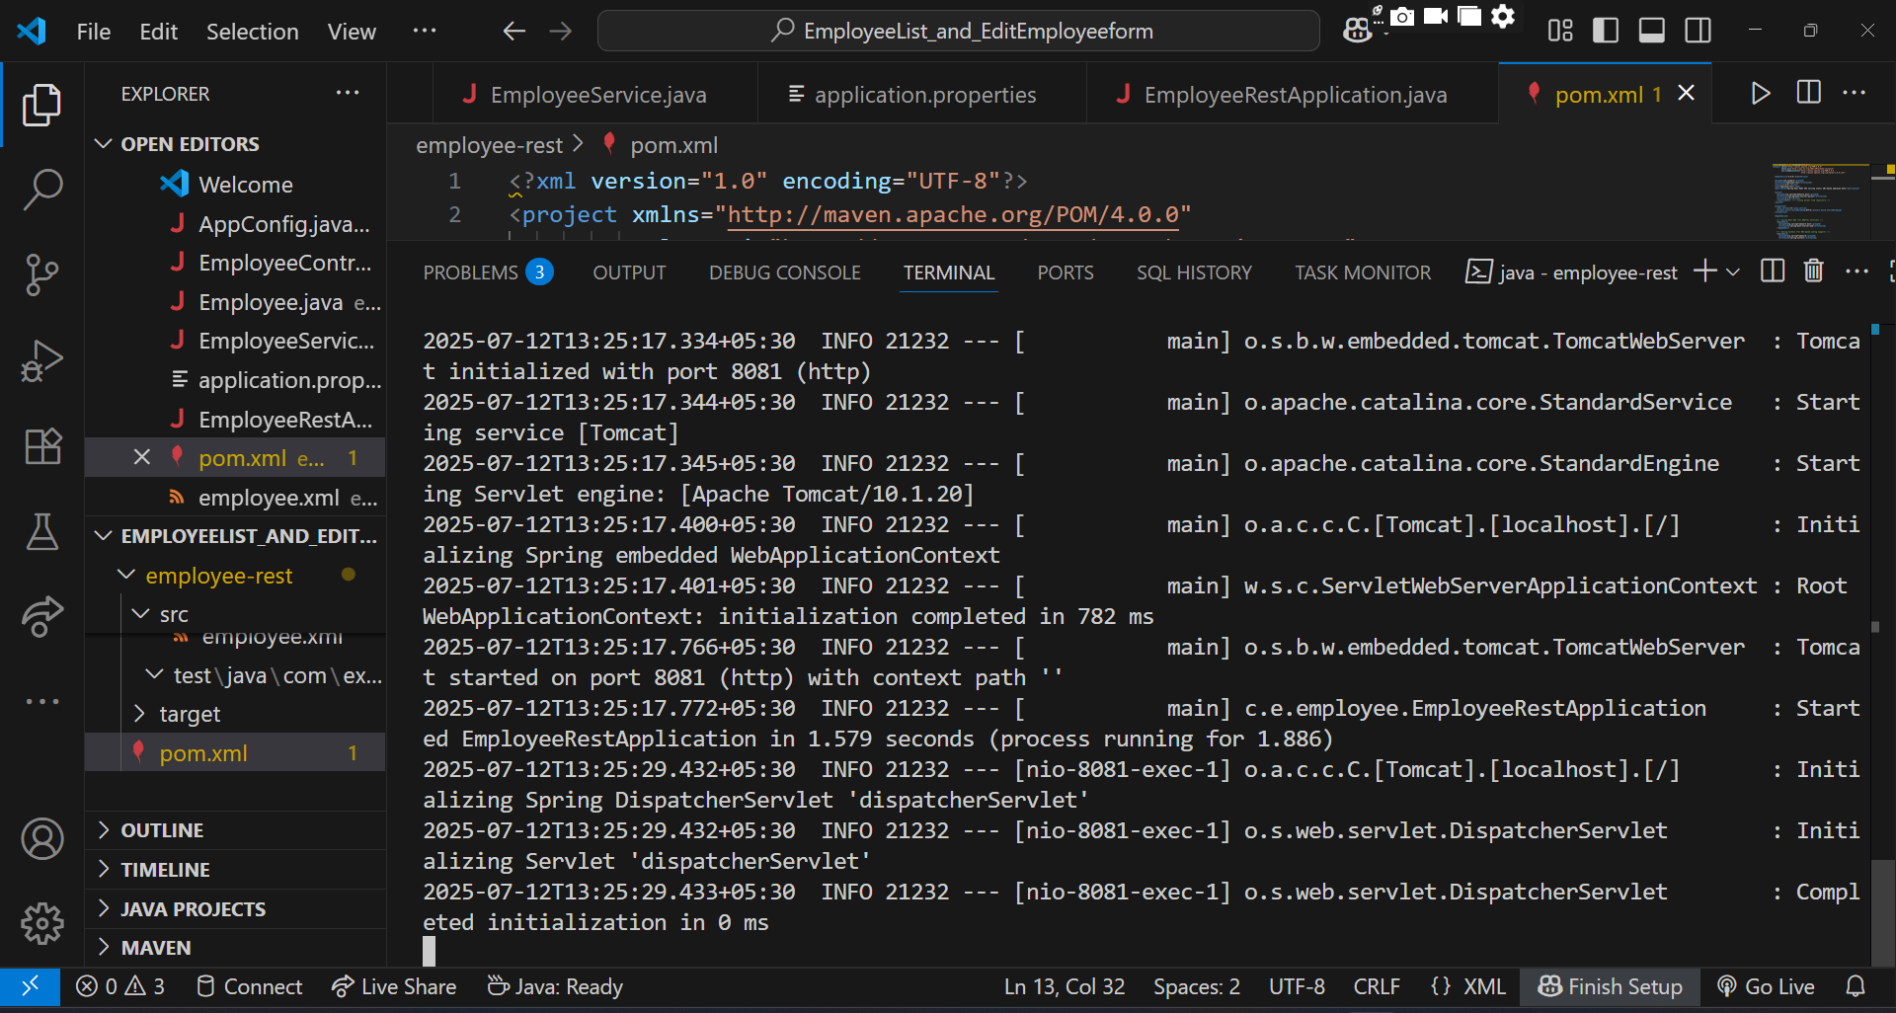

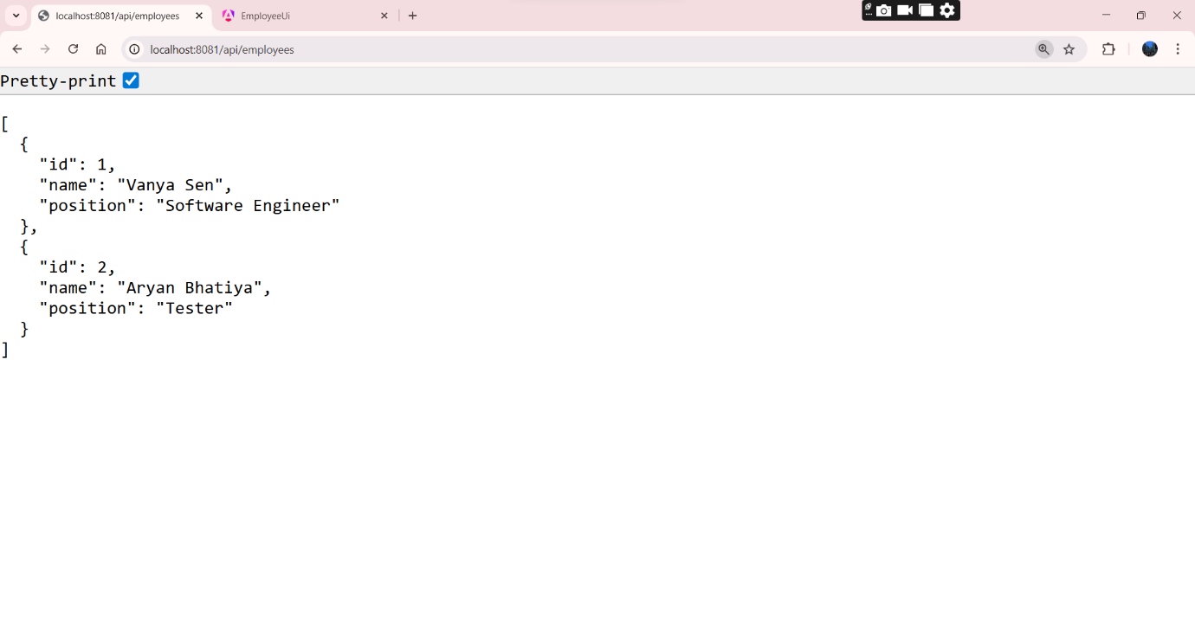

Frontend

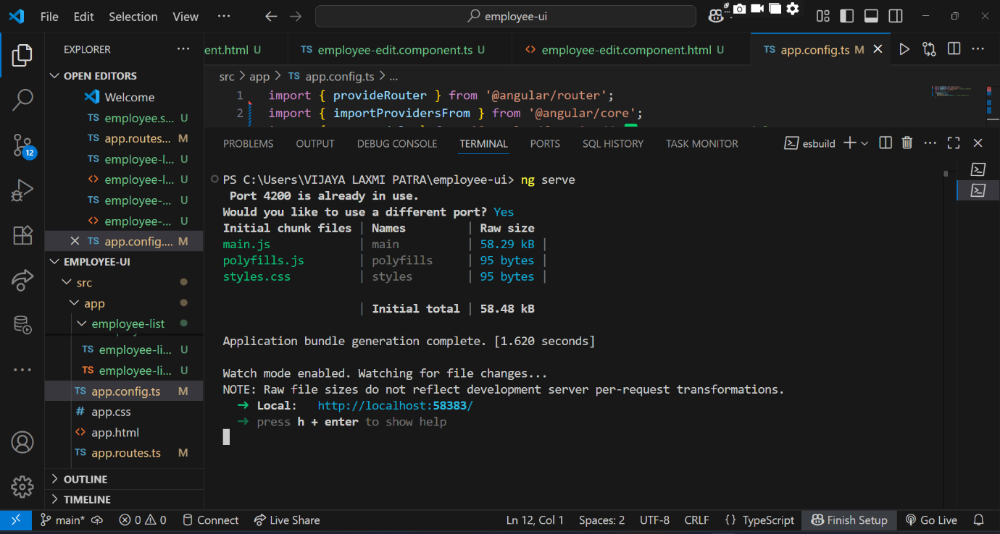

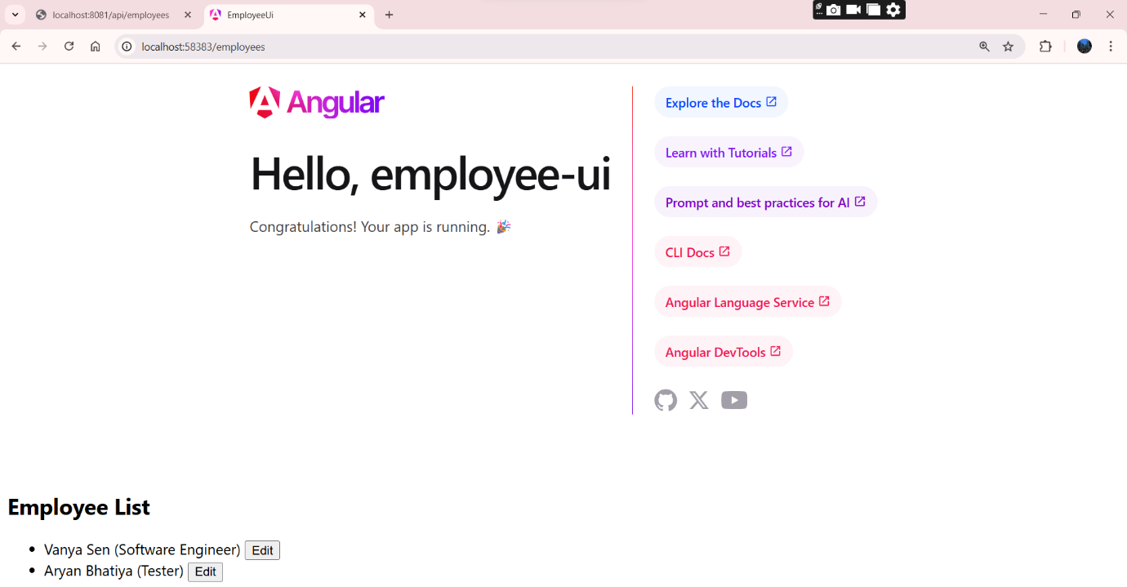

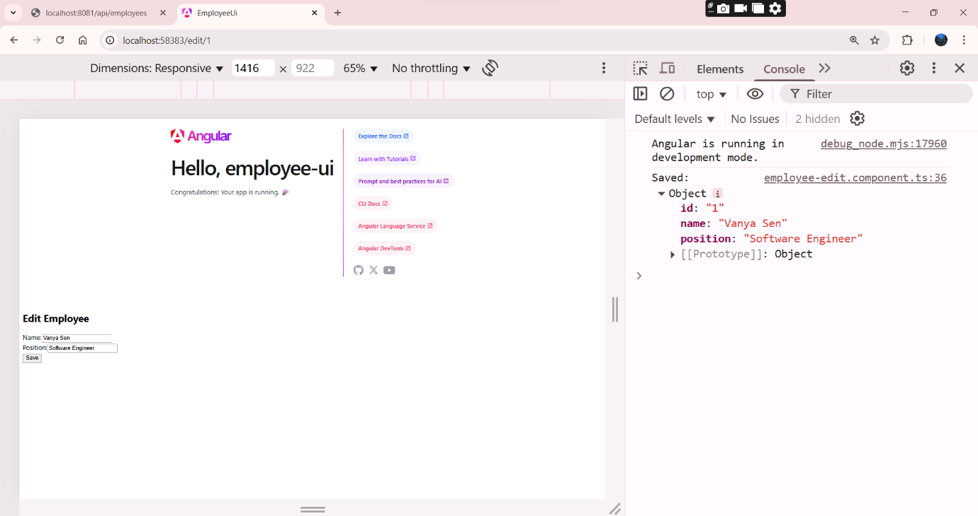

Angular Operating successfully:

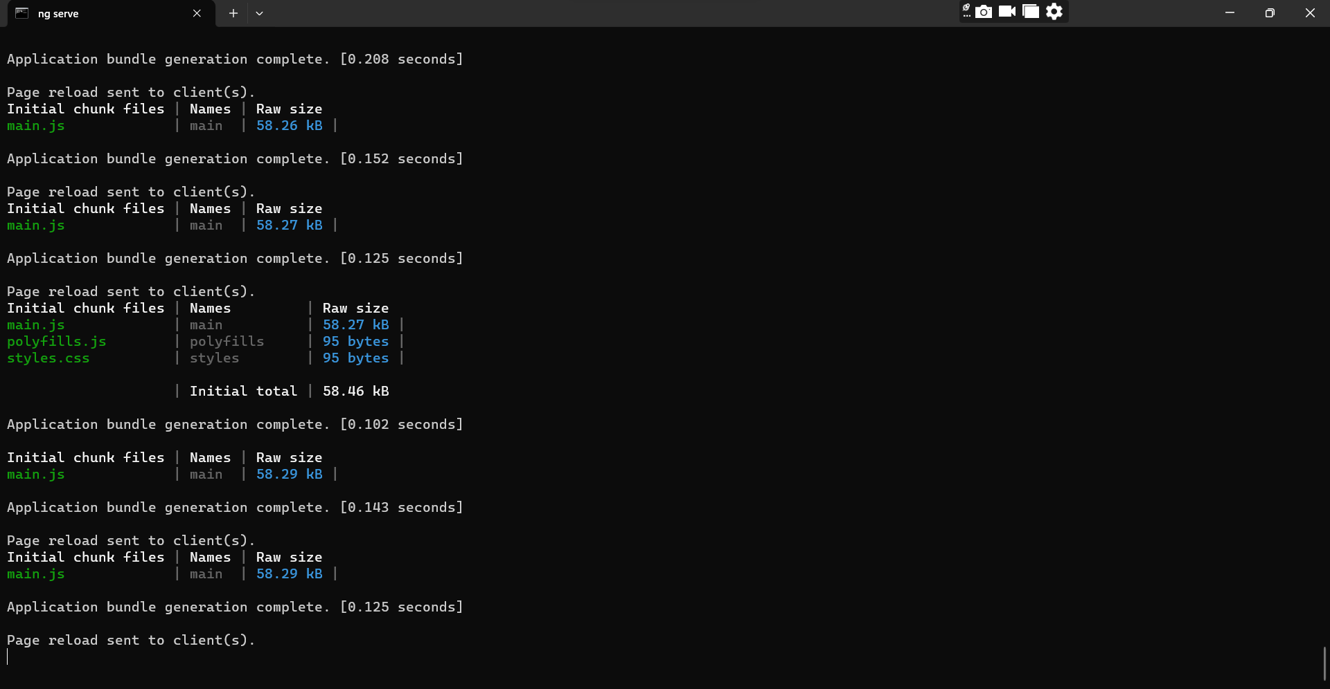

2). Create static employee list data using spring xml configuration

Department.java

package com.example.model;

public class Department {
private int id;
private String name;

public Department() {
}

public Department(int id, String name) {
this.id = id;
this.name = name;
}

public int getId() {
return id;
}

public String getName() {
return name;
}

public void setId(int id) {
this.id = id;
}

public void setName(String name) {
this.name = name;
}

@Override
public String toString() {
return "Department [id=" + id + ", name=" + name + "]";
}
}

Skill.java

package com.example.model;

public class Skill {
private int id;
private String name;

public Skill() {
}

public Skill(int id, String name) {
this.id = id;
this.name = name;
}

public int getId() {
return id;
}

public String getName() {
return name;
}

public void setId(int id) {
this.id = id;
}

public void setName(String name) {
this.name = name;
}

@Override
public String toString() {
return "Skill [id=" + id + ", name=" + name + "]";
}
}

Employee.java

package com.example.model;

import java.util.Date;
import java.util.List;

public class Employee {
private int id;
private String name;
private double salary;
private boolean permanent;
private Date dateOfBirth;
private Department department;
private List<Skill> skillList;

public Employee() {
}

public Employee(int id, String name, double salary, boolean permanent, Date dateOfBirth, Department department, List<Skill> skillList) {
this.id = id;
this.name = name;
this.salary = salary;
this.permanent = permanent;
this.dateOfBirth = dateOfBirth;
this.department = department;
this.skillList = skillList;
}

public int getId() {
return id;
}

public String getName() {
return name;
}

public double getSalary() {
return salary;
}

public boolean isPermanent() {
return permanent;
}

public Date getDateOfBirth() {
return dateOfBirth;
}

public Department getDepartment() {
return department;
}

public List<Skill> getSkillList() {
return skillList;
}

public void setId(int id) {
this.id = id;
}

public void setName(String name) {
this.name = name;
}

public void setSalary(double salary) {
this.salary = salary;
}

public void setPermanent(boolean permanent) {
this.permanent = permanent;
}

public void setDateOfBirth(Date dateOfBirth) {
this.dateOfBirth = dateOfBirth;
}

public void setDepartment(Department department) {
this.department = department;
}

public void setSkillList(List<Skill> skillList) {
this.skillList = skillList;
}

@Override
public String toString() {
return "Employee [id=" + id + ", name=" + name + ", salary=" + salary +
", permanent=" + permanent + ", dateOfBirth=" + dateOfBirth +
", department=" + department + ", skillList=" + skillList + "]";
}
}

Main.java

package com.example;

import com.example.model.Employee;
import com.example.model.EmployeeDao;

import java.util.List;

public class Main {
public static void main(String[] args) {
EmployeeDao dao = new EmployeeDao();
List<Employee> employees = dao.getAllEmployees();

System.out.println("Employee List:");
for (Employee e : employees) {
System.out.println(e);
}
}
}

EmployeeDao.java

package com.example.model;

import java.util.ArrayList;
import java.util.List;

import org.springframework.context.ApplicationContext;
import org.springframework.context.support.ClassPathXmlApplicationContext;

public class EmployeeDao {

public static List<Employee> EMPLOYEE_LIST;

public EmployeeDao() {
ApplicationContext context = new ClassPathXmlApplicationContext("employee.xml");
EMPLOYEE_LIST = (ArrayList<Employee>) context.getBean("employeeList");
}

public List<Employee> getAllEmployees() {
return EMPLOYEE_LIST;
}
}

employee.xml

<?xml version="1.0" encoding="UTF-8"?>
<beans xmlns="http://www.springframework.org/schema/beans"
xmlns:util="http://www.springframework.org/schema/util"
xmlns:xsi="http://www.w3.org/2001/XMLSchema-instance"
xsi:schemaLocation="
http://www.springframework.org/schema/beans
https://www.springframework.org/schema/beans/spring-beans.xsd
http://www.springframework.org/schema/util
https://www.springframework.org/schema/util/spring-util.xsd">

<bean id="dept1" class="com.example.model.Department">
<constructor-arg value="1"/>
<constructor-arg value="HR"/>
</bean>
<bean id="dept2" class="com.example.model.Department">
<constructor-arg value="2"/>
<constructor-arg value="Finance"/>
</bean>

<bean id="skill1" class="com.example.model.Skill">
<constructor-arg value="1"/>
<constructor-arg value="Java"/>
</bean>
<bean id="skill2" class="com.example.model.Skill">
<constructor-arg value="2"/>
<constructor-arg value="Angular"/>
</bean>

<util:list id="skillList1" list-class="java.util.ArrayList">
<ref bean="skill1"/>
<ref bean="skill2"/>
</util:list>

<bean id="emp1" class="com.example.model.Employee">
<property name="id" value="101"/>
<property name="name" value="Reyansh"/>
<property name="salary" value="50000"/>
<property name="permanent" value="true"/>
<property name="dateOfBirth">
<bean class="java.util.Date">
<constructor-arg value="1990/05/20"/>
</bean>
</property>
<property name="department" ref="dept1"/>
<property name="skillList" ref="skillList1"/>
</bean>

<bean id="emp2" class="com.example.model.Employee">
<property name="id" value="102"/>
<property name="name" value="Kavya"/>
<property name="salary" value="60000"/>
<property name="permanent" value="false"/>
<property name="dateOfBirth">
<bean class="java.util.Date">
<constructor-arg value="1992/03/12"/>
</bean>
</property>
<property name="department" ref="dept2"/>
<property name="skillList" ref="skillList1"/>
</bean>

<bean id="emp3" class="com.example.model.Employee">
<property name="id" value="103"/>
<property name="name" value="Aarav"/>
<property name="salary" value="55000"/>
<property name="permanent" value="true"/>
<property name="dateOfBirth">
<bean class="java.util.Date">
<constructor-arg value="1991/07/15"/>
</bean>
</property>
<property name="department" ref="dept1"/>
<property name="skillList" ref="skillList1"/>
</bean>

<bean id="emp4" class="com.example.model.Employee">
<property name="id" value="104"/>
<property name="name" value="Ira"/>
<property name="salary" value="65000"/>
<property name="permanent" value="false"/>
<property name="dateOfBirth">
<bean class="java.util.Date">
<constructor-arg value="1994/10/10"/>
</bean>
</property>
<property name="department" ref="dept2"/>
<property name="skillList" ref="skillList1"/>
</bean>

<util:list id="employeeList" list-class="java.util.ArrayList">
<ref bean="emp1"/>
<ref bean="emp2"/>
<ref bean="emp3"/>
<ref bean="emp4"/>
</util:list>
</beans>

pom.xml

<?xml version="1.0" encoding="UTF-8"?>

<project xmlns="http://maven.apache.org/POM/4.0.0"
xmlns:xsi="http://www.w3.org/2001/XMLSchema-instance"
xsi:schemaLocation="http://maven.apache.org/POM/4.0.0
http://maven.apache.org/xsd/maven-4.0.0.xsd">
<modelVersion>4.0.0</modelVersion>

<groupId>com.example</groupId>
<artifactId>employee-static-list</artifactId>
<version>1.0</version>
<name>employee-static-list</name>

<properties>
<project.build.sourceEncoding>UTF-8</project.build.sourceEncoding>
<maven.compiler.source>1.8</maven.compiler.source>
<maven.compiler.target>1.8</maven.compiler.target>
</properties>

<dependencies>
<!-- Spring Core -->
<dependency>
<groupId>org.springframework</groupId>
<artifactId>spring-core</artifactId>
<version>5.3.33</version>
</dependency>

<!-- Spring Context (needed for ApplicationContext, beans, etc.) -->
<dependency>
<groupId>org.springframework</groupId>
<artifactId>spring-context</artifactId>
<version>5.3.33</version>
</dependency>

<!-- Spring Beans (optional, included via context, but can add explicitly) -->
<dependency>
<groupId>org.springframework</groupId>
<artifactId>spring-beans</artifactId>
<version>5.3.33</version>
</dependency>

<!-- JUnit for testing -->
<dependency>
<groupId>junit</groupId>
<artifactId>junit</artifactId>
<version>4.11</version>
<scope>test</scope>
</dependency>
</dependencies>

<build>
<plugins>
<!-- Maven Compiler -->
<plugin>
<groupId>org.apache.maven.plugins</groupId>
<artifactId>maven-compiler-plugin</artifactId>
<version>3.8.0</version>
</plugin>

<!-- Maven Exec Plugin to run Java Main class -->
<plugin>
<groupId>org.codehaus.mojo</groupId>
<artifactId>exec-maven-plugin</artifactId>
<version>3.1.0</version>
<configuration>
<mainClass>com.example.Main</mainClass>
</configuration>
</plugin>
</plugins>
</build>
</project>

OUTPUT:

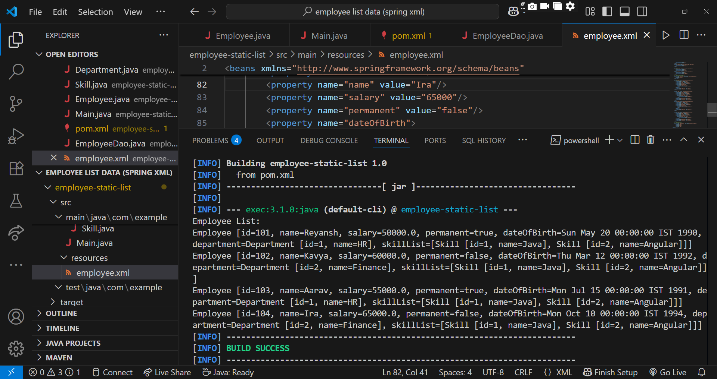

3). Create REST service to gets all employees

EmployeeController.java

package com.example.employee.controller;

import com.example.employee.model.Employee;
import com.example.employee.service.EmployeeService;
import org.springframework.beans.factory.annotation.Autowired;
import org.springframework.web.bind.annotation.*;

import java.util.List;

@RestController
public class EmployeeController {

@Autowired
private EmployeeService employeeService;

@GetMapping("/employees")
public List<Employee> getAllEmployees() {
return employeeService.getAllEmployees();
}
}

EmployeeDao.java

package com.example.employee.dao;

import com.example.employee.model.Employee;
import org.springframework.stereotype.Repository;

import java.util.ArrayList;
import java.util.List;

@Repository
public class EmployeeDao {

private static final List<Employee> EMPLOYEE_LIST = new ArrayList<>();

static {
EMPLOYEE_LIST.add(new Employee(1, "Aryan Bhatiya", "HR"));
EMPLOYEE_LIST.add(new Employee(2, "Vanya Sen", "IT"));
EMPLOYEE_LIST.add(new Employee(3, "Depinder Chhibber", "Finance"));
EMPLOYEE_LIST.add(new Employee(4, "Ayrav Gupta", "IT"));
}

public List<Employee> getAllEmployees() {
return EMPLOYEE_LIST;
}
}

Employee.java

package com.example.employee.model;

public class Employee {
private int id;
private String name;
private String department;

public Employee() {}
public Employee(int id, String name, String department) {
this.id = id;
this.name = name;
this.department = department;
}

public int getId() { return id; }
public void setId(int id) { this.id = id; }

public String getName() { return name; }
public void setName(String name) { this.name = name; }

public String getDepartment() { return department; }
public void setDepartment(String department) { this.department = department; }
}

EmployeeService.java

package com.example.employee.service;

import com.example.employee.dao.EmployeeDao;
import com.example.employee.model.Employee;
import org.springframework.beans.factory.annotation.Autowired;
import org.springframework.stereotype.Service;
import org.springframework.transaction.annotation.Transactional;

import java.util.List;

@Service
public class EmployeeService {

@Autowired
private EmployeeDao employeeDao;

@Transactional
public List<Employee> getAllEmployees() {
return employeeDao.getAllEmployees();
}
}

EmployeeRestApplication.java

package com.example.employee;

import org.springframework.boot.SpringApplication;
import org.springframework.boot.autoconfigure.SpringBootApplication;

@SpringBootApplication
public class EmployeeRestApplication {
public static void main(String[] args) {
SpringApplication.run(EmployeeRestApplication.class, args);
}
}

application.properties

server.port=9090

pom.xml

<?xml version="1.0" encoding="UTF-8"?>

<project xmlns="http://maven.apache.org/POM/4.0.0"
xmlns:xsi="http://www.w3.org/2001/XMLSchema-instance"
xsi:schemaLocation="http://maven.apache.org/POM/4.0.0
http://maven.apache.org/xsd/maven-4.0.0.xsd">

<modelVersion>4.0.0</modelVersion>

<groupId>com.example</groupId>
<artifactId>employee-rest</artifactId>
<version>1.0.0</version>
<packaging>jar</packaging>

<name>employee-rest</name>
<description>Spring Boot REST service for Employee List</description>

<parent>
<groupId>org.springframework.boot</groupId>
<artifactId>spring-boot-starter-parent</artifactId>
<version>2.7.18</version>
<relativePath/>
</parent>

<properties>
<java.version>1.8</java.version>
</properties>

<dependencies>

<dependency>
<groupId>org.springframework.boot</groupId>
<artifactId>spring-boot-starter-web</artifactId>
</dependency>

<dependency>
<groupId>org.springframework</groupId>
<artifactId>spring-tx</artifactId>
</dependency>

<dependency>
<groupId>org.springframework.boot</groupId>
<artifactId>spring-boot-starter-test</artifactId>
<scope>test</scope>
</dependency>
</dependencies>

<build>
<plugins>

<plugin>
<groupId>org.springframework.boot</groupId>
<artifactId>spring-boot-maven-plugin</artifactId>
</plugin>
</plugins>
</build>
</project>

OUTPUT:

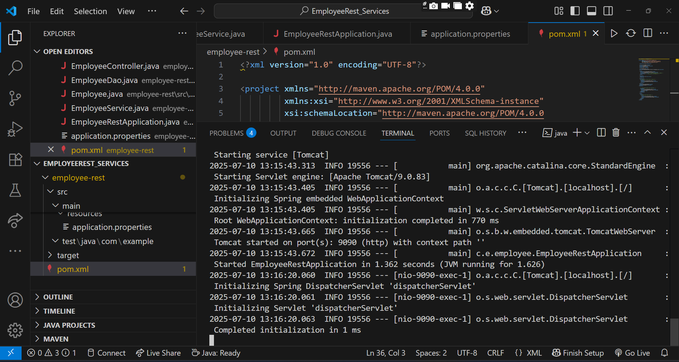

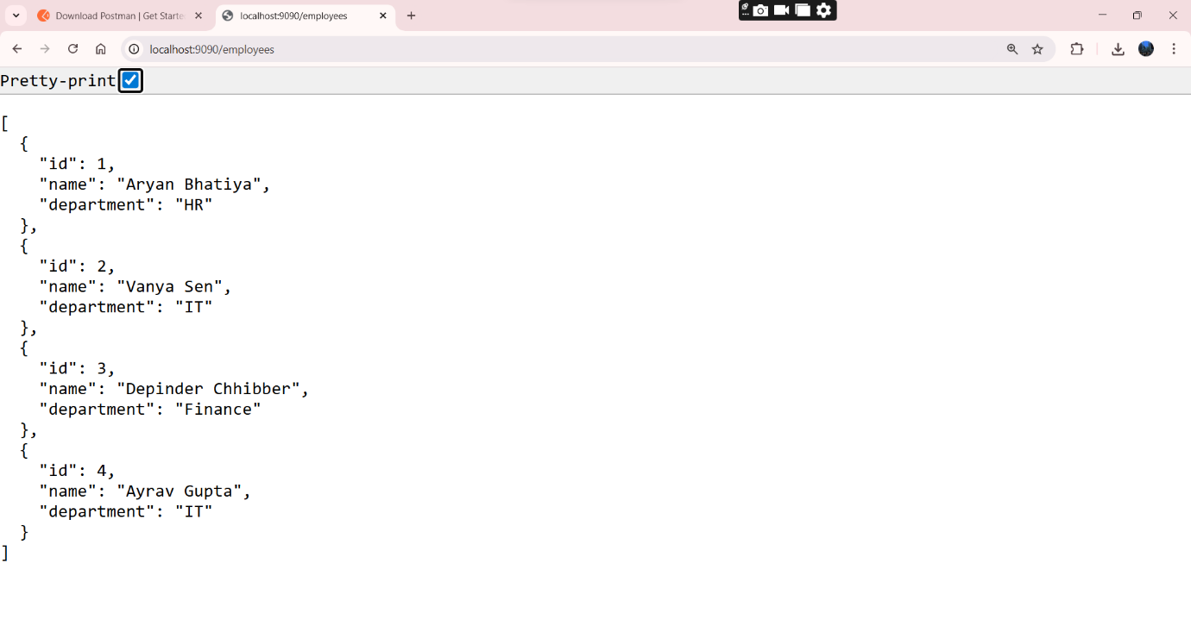

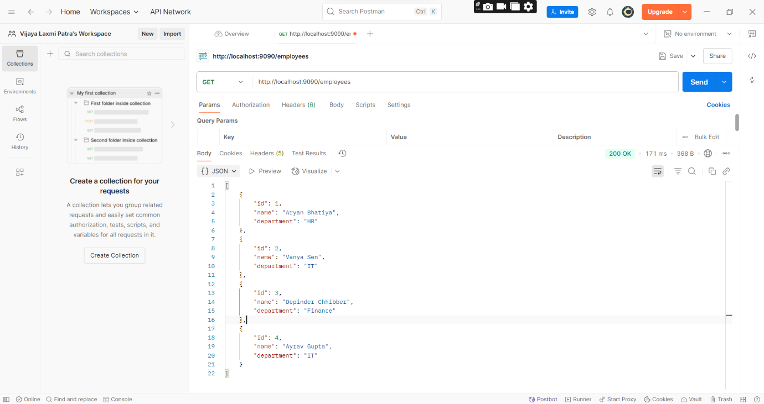

4). Create REST service for department

DepartmentController.java

package com.example.department.controller;

import com.example.department.model.Department;
import com.example.department.service.DepartmentService;
import org.springframework.beans.factory.annotation.Autowired;
import org.springframework.web.bind.annotation.*;

import java.util.List;

@RestController
public class DepartmentController {

@Autowired
private DepartmentService departmentService;

@GetMapping("/departments")
public List<Department> getAllDepartments() {
System.out.println("Fetching all departments...");
return departmentService.getAllDepartments();
}
}

DepartmentService.java

package com.example.department.service;

import com.example.department.dao.DepartmentDao;
import com.example.department.model.Department;
import org.springframework.beans.factory.annotation.Autowired;
import org.springframework.stereotype.Service;

import java.util.List;

@Service
public class DepartmentService {

@Autowired
private DepartmentDao departmentDao;

public List<Department> getAllDepartments() {
return departmentDao.getAllDepartments();
}
}

DepartmentDao.java

package com.example.department.dao;

import com.example.department.model.Department;
import org.springframework.beans.factory.annotation.Autowired;
import org.springframework.beans.factory.annotation.Qualifier;
import org.springframework.stereotype.Repository;

import java.util.List;

@Repository
public class DepartmentDao {

@Autowired
@Qualifier("departmentList")
private List<Department> departmentList;

public List<Department> getAllDepartments() {
return departmentList;
}
}

Department.java

package com.example.department.model;

public class Department {
private String code;
private String name;

public Department() {}

public Department(String code, String name) {
this.code = code;
this.name = name;
}

public String getCode() { return code; }
public void setCode(String code) { this.code = code; }

public String getName() { return name; }
public void setName(String name) { this.name = name; }
}

DepartmentApplication.java

package com.example.department;

import org.springframework.boot.SpringApplication;
import org.springframework.boot.autoconfigure.SpringBootApplication;
import org.springframework.context.annotation.ImportResource;

@SpringBootApplication
@ImportResource("classpath:department.xml")
public class DepartmentApplication {

public static void main(String[] args) {
SpringApplication.run(DepartmentApplication.class, args);
System.out.println("Department Service Started...");
}
}

department.xml

<?xml version="1.0" encoding="UTF-8"?>
<beans xmlns="http://www.springframework.org/schema/beans"
xmlns:util="http://www.springframework.org/schema/util"
xmlns:xsi="http://www.w3.org/2001/XMLSchema-instance"
xsi:schemaLocation="
http://www.springframework.org/schema/beans
http://www.springframework.org/schema/beans/spring-beans.xsd
http://www.springframework.org/schema/util
http://www.springframework.org/schema/util/spring-util.xsd">

<util:list id="departmentList" value-type="com.example.department.model.Department">
<bean class="com.example.department.model.Department">
<property name="code" value="CSE"/>
<property name="name" value="Computer Science"/>
</bean>
<bean class="com.example.department.model.Department">
<property name="code" value="ECE"/>
<property name="name" value="Electronics"/>
</bean>
</util:list>
</beans>

application.properties

server.port=9090

pom.xml

<?xml version="1.0" encoding="UTF-8"?>
<project xmlns="http://maven.apache.org/POM/4.0.0"
xmlns:xsi="http://www.w3.org/2001/XMLSchema-instance"
xsi:schemaLocation="http://maven.apache.org/POM/4.0.0
http://maven.apache.org/xsd/maven-4.0.0.xsd">

<modelVersion>4.0.0</modelVersion>

<groupId>com.example</groupId>
<artifactId>spring-boot-department-service</artifactId>
<version>1.0.0</version>
<packaging>jar</packaging>

<name>spring-boot-department-service</name>
<description>Spring Boot REST Service to get all departments</description>

<parent>
<groupId>org.springframework.boot</groupId>
<artifactId>spring-boot-starter-parent</artifactId>
<version>3.1.1</version>
<relativePath/>
</parent>

<properties>
<java.version>17</java.version>
</properties>

<dependencies>

<dependency>
<groupId>org.springframework.boot</groupId>
<artifactId>spring-boot-starter-web</artifactId>
</dependency>

<dependency>
<groupId>org.springframework</groupId>
<artifactId>spring-context</artifactId>
</dependency>

<dependency>
<groupId>org.junit.jupiter</groupId>
<artifactId>junit-jupiter</artifactId>
<version>5.9.2</version>
<scope>test</scope>
</dependency>
</dependencies>

<build>
<plugins>

<plugin>
<groupId>org.springframework.boot</groupId>
<artifactId>spring-boot-maven-plugin</artifactId>
<version>3.1.1</version>
</plugin>
</plugins>
</build>

</project>

OUTPUT:

